PFC - Workshop 01

Q1 (8 marks). Write a program that performs the following tasks:
- Input 4 real numbers a, b, c and x.
- Calculate S1 = ax² + bx + c.
- Calculate S2 = 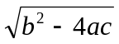 if b*b - 4ac > 0, otherwise S2 = 0
- Re-input a, b and c. Check whether a, b and c are sides of a triangle or not.
- If a, b, c are sides of a triangle, then calculate its perimeter and area, otherwise display on the screen a message "a, b, c are not side of a triangle". The area is calculated by the Heron formula below:
S1 = 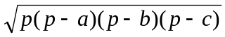, where 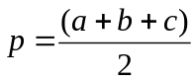

Sample input and output:
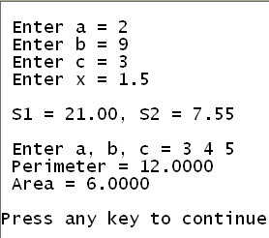 | 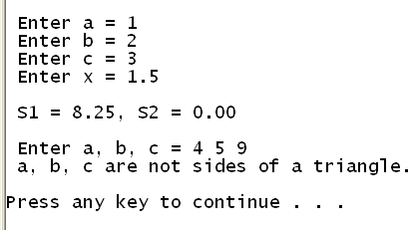

Additional questions (2 marks):
Q2. Write a program to accept 3 real numbers a, b, c, then:
- Display the maximum and minimum values among them.
- Arrange them in ascending order, i.e. a ≤ b ≤ c.

